CROATIAN PHYSIOLOGICAL SOCIETY
tel: 01/2390-170; Heinzelova 55, 10 000 Zagreb
contact: aleksandra.dugandzic@mef.hr
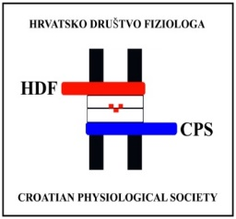
Registration Form
For the 3rd Regional Congress of Physiological Societies and the 5th Congress of Croatian Physiological Society (September 22 – 25, 2022)
Personal information
Name:
Surname:
Title:
Institution:
Country:
Address:
E-mail:
Registration (Please mark the preferred option)
I would like to register:
- For the entire conference duration
  - As a member of the Croatian Physiological Society (early registration fee: 50 Eur / 375 kn; late registration fee: 100 Eur / 750 kn)
  - As a non-member of the Croatian Physiological Society (early registration fee: 75 Eur / 560 kn; late registration fee: 125 Eur / 940 kn)
  - As a doctoral student and a member of the Croatian Physiological Society (early registration fee: 40 Eur / 300 kn; late registration fee: 50 Eur / 375 kn)
  - As a doctoral student and a non-member of the Croatian Physiological Society (early registration fee: 50 Eur / 375 kn; late registration fee: 75 Eur / 560 kn)

- To attend one day
  - As a doctoral student (daily registration fee: 30 Eur /225 kn)
  - As a post-doctoral researcher (daily registration fee: 40 Eur /300 kn)

Participation
Please select type of participation in the conference:
- Oral presentation
- Poster presentation
- Passive participation

I give my consent for publishing my abstract online (Yes/No)?

Date: Signature:

